PUBLISH DATA TO THE IBM CLOUD

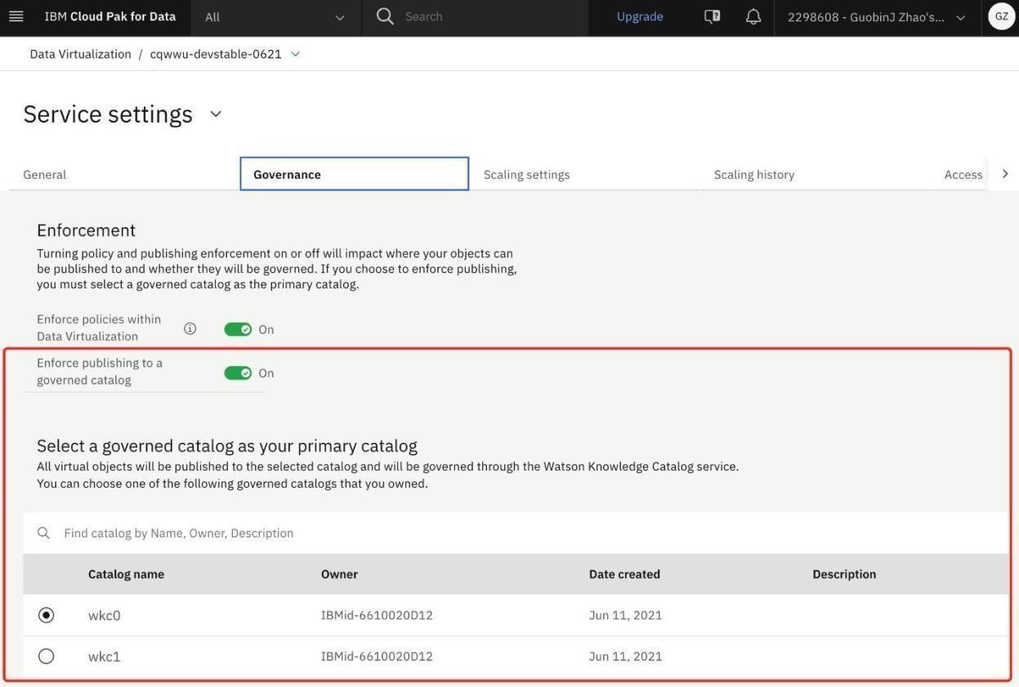

|  |  |
| --- | --- |
| Date | 22 November 2022 |
| Team ID | PNT2022TMID16894 |
| Project Name | Project – IOT Based Real – time River Water Quality Monitoring and Control  System |
| Maximum Marks | 4 Marks |

By publishing your virtual data to a catalog, you can:

* *Organize, label, classify, and search for the published data assets with global search.
* *Govern the virtual data asset and subject it to data protection rules by [enabling policy](https://www.ibm.com/docs/en/SSQNUZ_4.5.x/svc-dv/enable-strict.html) [enforcement i](https://www.ibm.com/docs/en/SSQNUZ_4.5.x/svc-dv/enable-strict.html)n Data
* *Navigate to **Service settings**.
* *On the **Governance** tab, enable the **Enforce publishing to a governed catalog** option.
* A list of governed catalogs that you have Admin access to is shown. You must select a governed catalog as your primary catalog. When you set a primary catalog, all

1. On the service menu, click **Virtualization** > **Virtualized data**.
2. Select the virtual objects that you want to publish and click **Publish to catalog**.

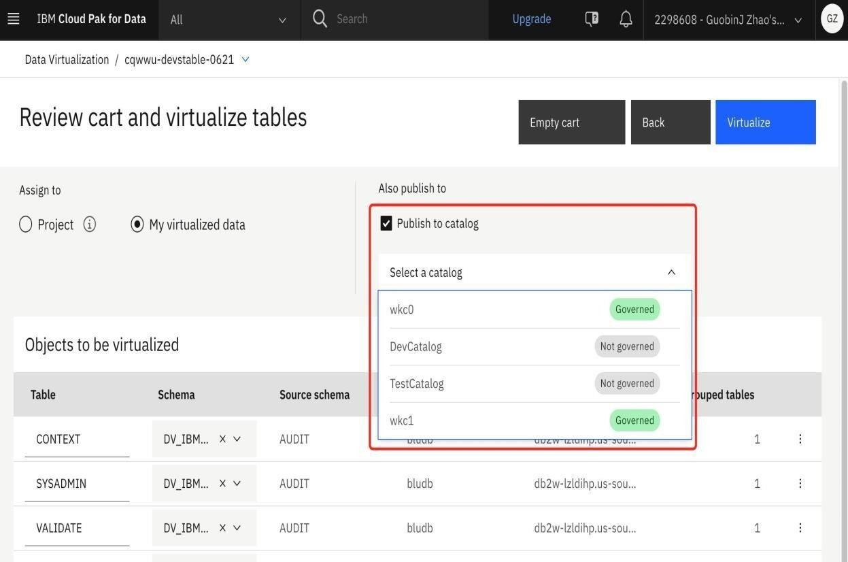

1. Continue with the virtualization process